STRINGS IN PYTHON

String literals are enclosed in triple quotations (‘’’hello’’’) double quotations (eg. “hello”) or single quotations (eg. ‘hello’)

String literals enclosed in triple quotes or double quotes can span multiple lines of text but they must be ended with escape sequences.

Characters in a string can be accessed using the standard [ ] syntax, and like Java and C++, Python uses zero-based indexing, so if str is 'hello' str[1] is 'e'.
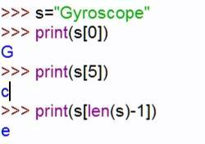

Printing any character beyond the range [0,len(s)) gives an index out of bounds error (Try it yourself!!)

But the above statement is not completely correct!! Why?? You will know that later.

Python strings are “immutable” which means strings can’t be changed after they are created.
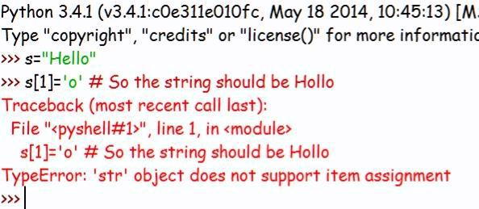
STRING MANIPULATION

Concatenation (‘+’ operator)

‘+’ operator is used for joining strings
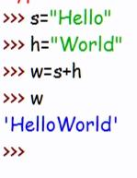

Multiplication (‘*’ operator)

W=s*(n) n is a +ve integer

Makes n copies of given string(s) and concatenates it to the end
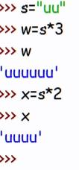

FORMATTING/DATA-BINDING with .format

Placeholder formatting

Placeholders |  | Arguments
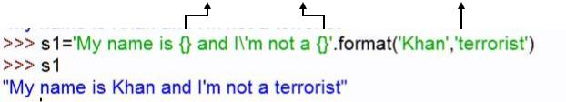
Rearranging the order of display without changing the arguments
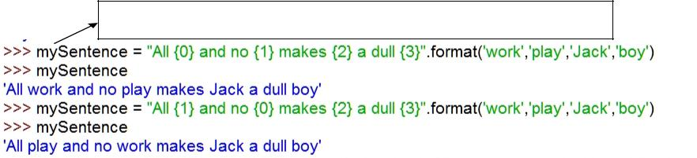
This type of variable naming has a name. Find out??

ESCAPE SEQUENCES

Escape Sequence are sequence of characters that give a special meaning to the compiler or create a sequence of characters that cannot be typed from the keyboard.

List of escape sequences that you should know and remember:-

ESCAPE | FUNCTION
\n | New line
\t | Tab space
\\ | Backslash
\’ | Single quote
\” | Double quote
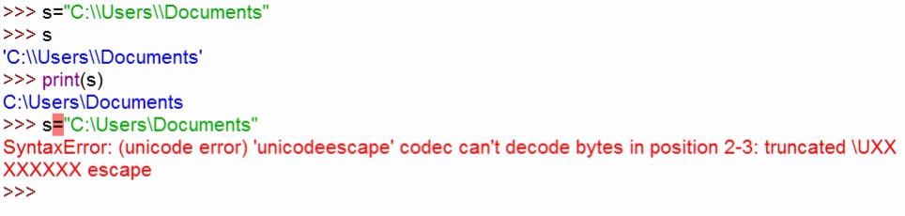
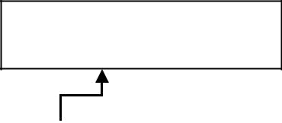

\n prints in a line
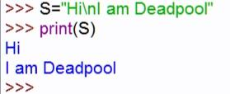

TYPE CASTING

It means converting a variable value from one data type to another. It is done using functions like int(),float() and str()

The need for type casting:-Code: s=”Agent”+47

Output: Error -> TypeError: cannot concatenate 'str' and 'int' objects

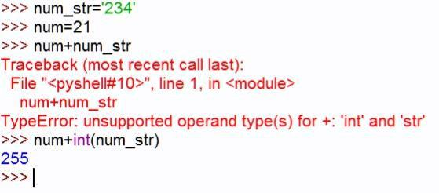
Correct Code s=”Agent”+str(47)

